Cure and prevention  How to stop the Black Death | Causes  Why did the Black Death happen?
- Fleas passing the disease from rats to humans  | - God’s punishment for sins such as gambling, swearing, money-lending, and fighting 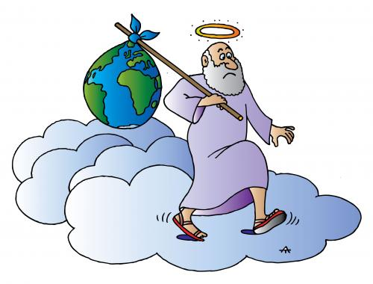
- Dirty towns with heaps of rubbish everywhere.  | - Ringing bells to pass on bad air
- Slicing open your boil and burning it with a red hot poker  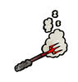 | - Cleaning the streets 
- It started in the East when frogs, snakes, lizards and scorpions fell from the sky- followed by thunder and lightning and fire  | - Shaving a live chicken’s bottom and attaching it to your boils  